**DAILY ONLINE ACTIVITIES SUMMARY**

|  |  |  |  |  |  |  |  |  |
| --- | --- | --- | --- | --- | --- | --- | --- | --- |
| **Date:** | **20/06/2020** | | | | | **Name:** | **K ISHA HEGDE** | |
| **Sem & Sec** | **4th SEM 'A' Section** | | | | | **USN:** | **4AL18CS031** | |
| **Online Test Summary** | | | | | | | | |
| **Subject** | | Data Communication | | | | | | |
| **Max. Marks** | | 30 | | **Score** | | | 28 | |
| **Certification Course Summary** | | | | | | | | |
| **Course** | **INTRODUCTION TO DIGITAL MARKETING** | | | | | | | |
| **Certificate Provider** | | | **GOOGLE DIGITAL GARAGE** | | **Duration** | | | **3 hour** |
| **Coding Challenges** | | | | | | | | |
| **Problem Statement:** 1. Write a C Program to rotate an array by K positions.  .  For example | | | | | | | | |
| **Status: completed** | | | | | | | | |
| **Uploaded the report in Github** | | | | | **Yes** | | | |
| **If yes Repository name** | | | | | [**https://github.com/iishaii/locked-down_coding**](https://github.com/iishaii/locked-down_coding) | | | |
| **Uploaded the report in slack** | | | | | **yes** | | | |

ONLINE TEST DETAILS: Online test was conducted on third and fourth module of **Data Communication**. Test contains 30 questions of 1 mark each. I have scored 27 Marks.

Snapshot:

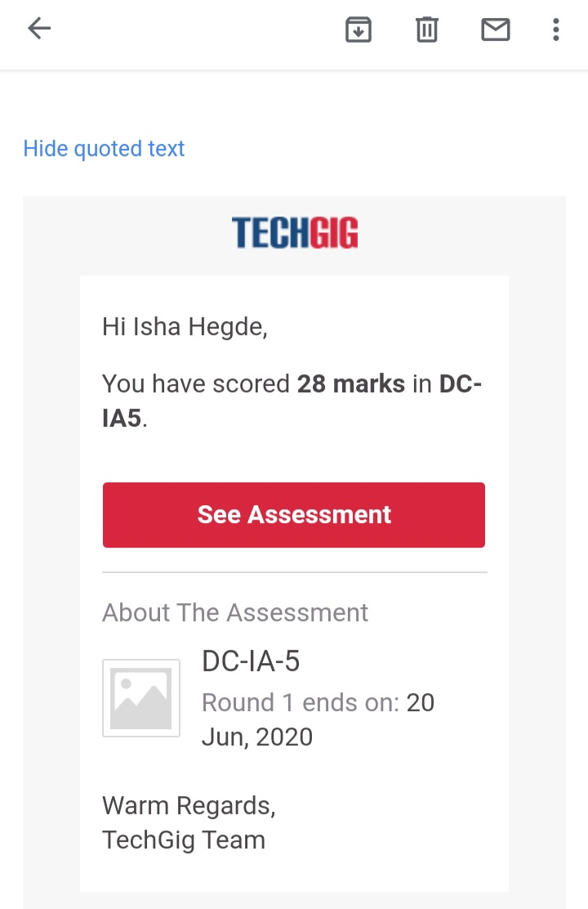

Certification Course Details: As the continuation of online course, I have completed the 6,7,8,9,10 modules of digital security awareness.



CODING CHALLENGES DETAILS: Problem statements

1. Write a C Program to rotate an array by K positions.

Solution: Uploaded it in github

Snapshot:

